**Mobile Game Development for Android GUI Design**

* **Create a game design through the light of the following topics**

**i-) What is your game is about?**

**İİ-) Which Platform are you going to use and why? Is the platform that you are selecting is satisfying to develop your game (Create a simple game in your platform to check weather the platform is sufficient to develop your game)**

**iii-) Based on your proposal specified below (See Abstract Section) design the Prototyping – Paper prototyping- of your game :** **a paper version of a UI**

* **Abstract Section**

**The initial work to be done is as follows:**

* **Propose a novel/original game with following minimum requirements**
  + **Your game should include levels, scoring, statistics, how to play etc.**
  + **Minimum 2 players or Artificial Intelligence (Computer versus) + 1.**
* **Write down the rules for your game**
  + **Design initial wireframe/story boards or any similar pattern to explain the proposed game.**
* **Compare with existing games that are similar to the proposed game.**
* **Specific advantages and disadvantages of the proposed game over the similar existing games**

**iV-) Example full paper prototype is as shown in *Figure-1*.**

* **What will be included in your Game draw your paper prototypes**

**V-) Specify the scenarios (Scenes(in Scene-1 ..., in Scene-2..., etc), backgrounds, text, images(may be characters), sounds, videos and animations in your scenes)**

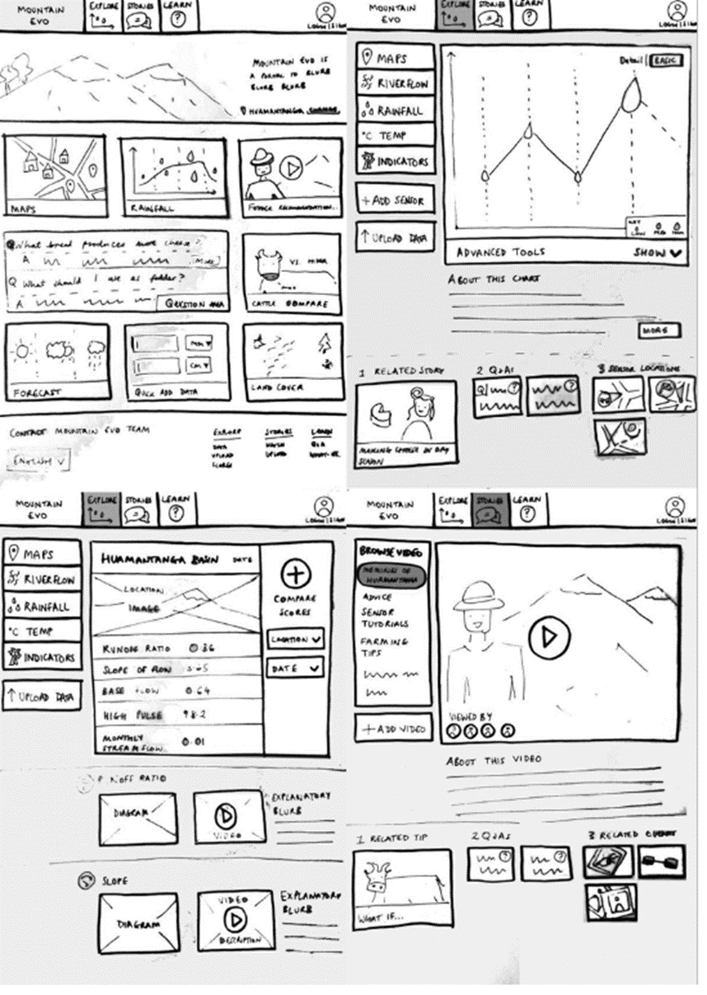

***Figure-1:* Full paper prototype sample**

**Vi-) How will be the general GUI appearance of your game for Android Mobiles**



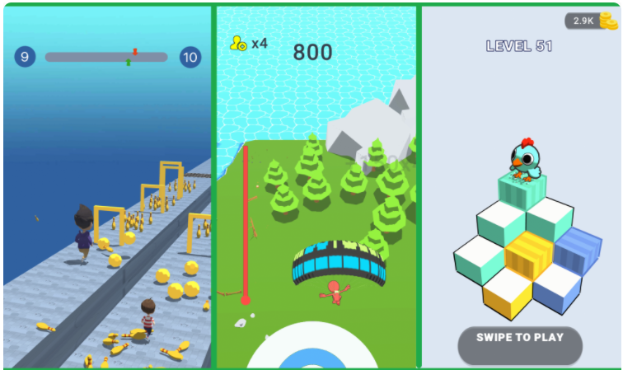

***Figure-2:* Sample GUI Appearance**